Conversion of Borneol to Camphor
Jacey Cochran
11/28/2023
Chem 2081-003

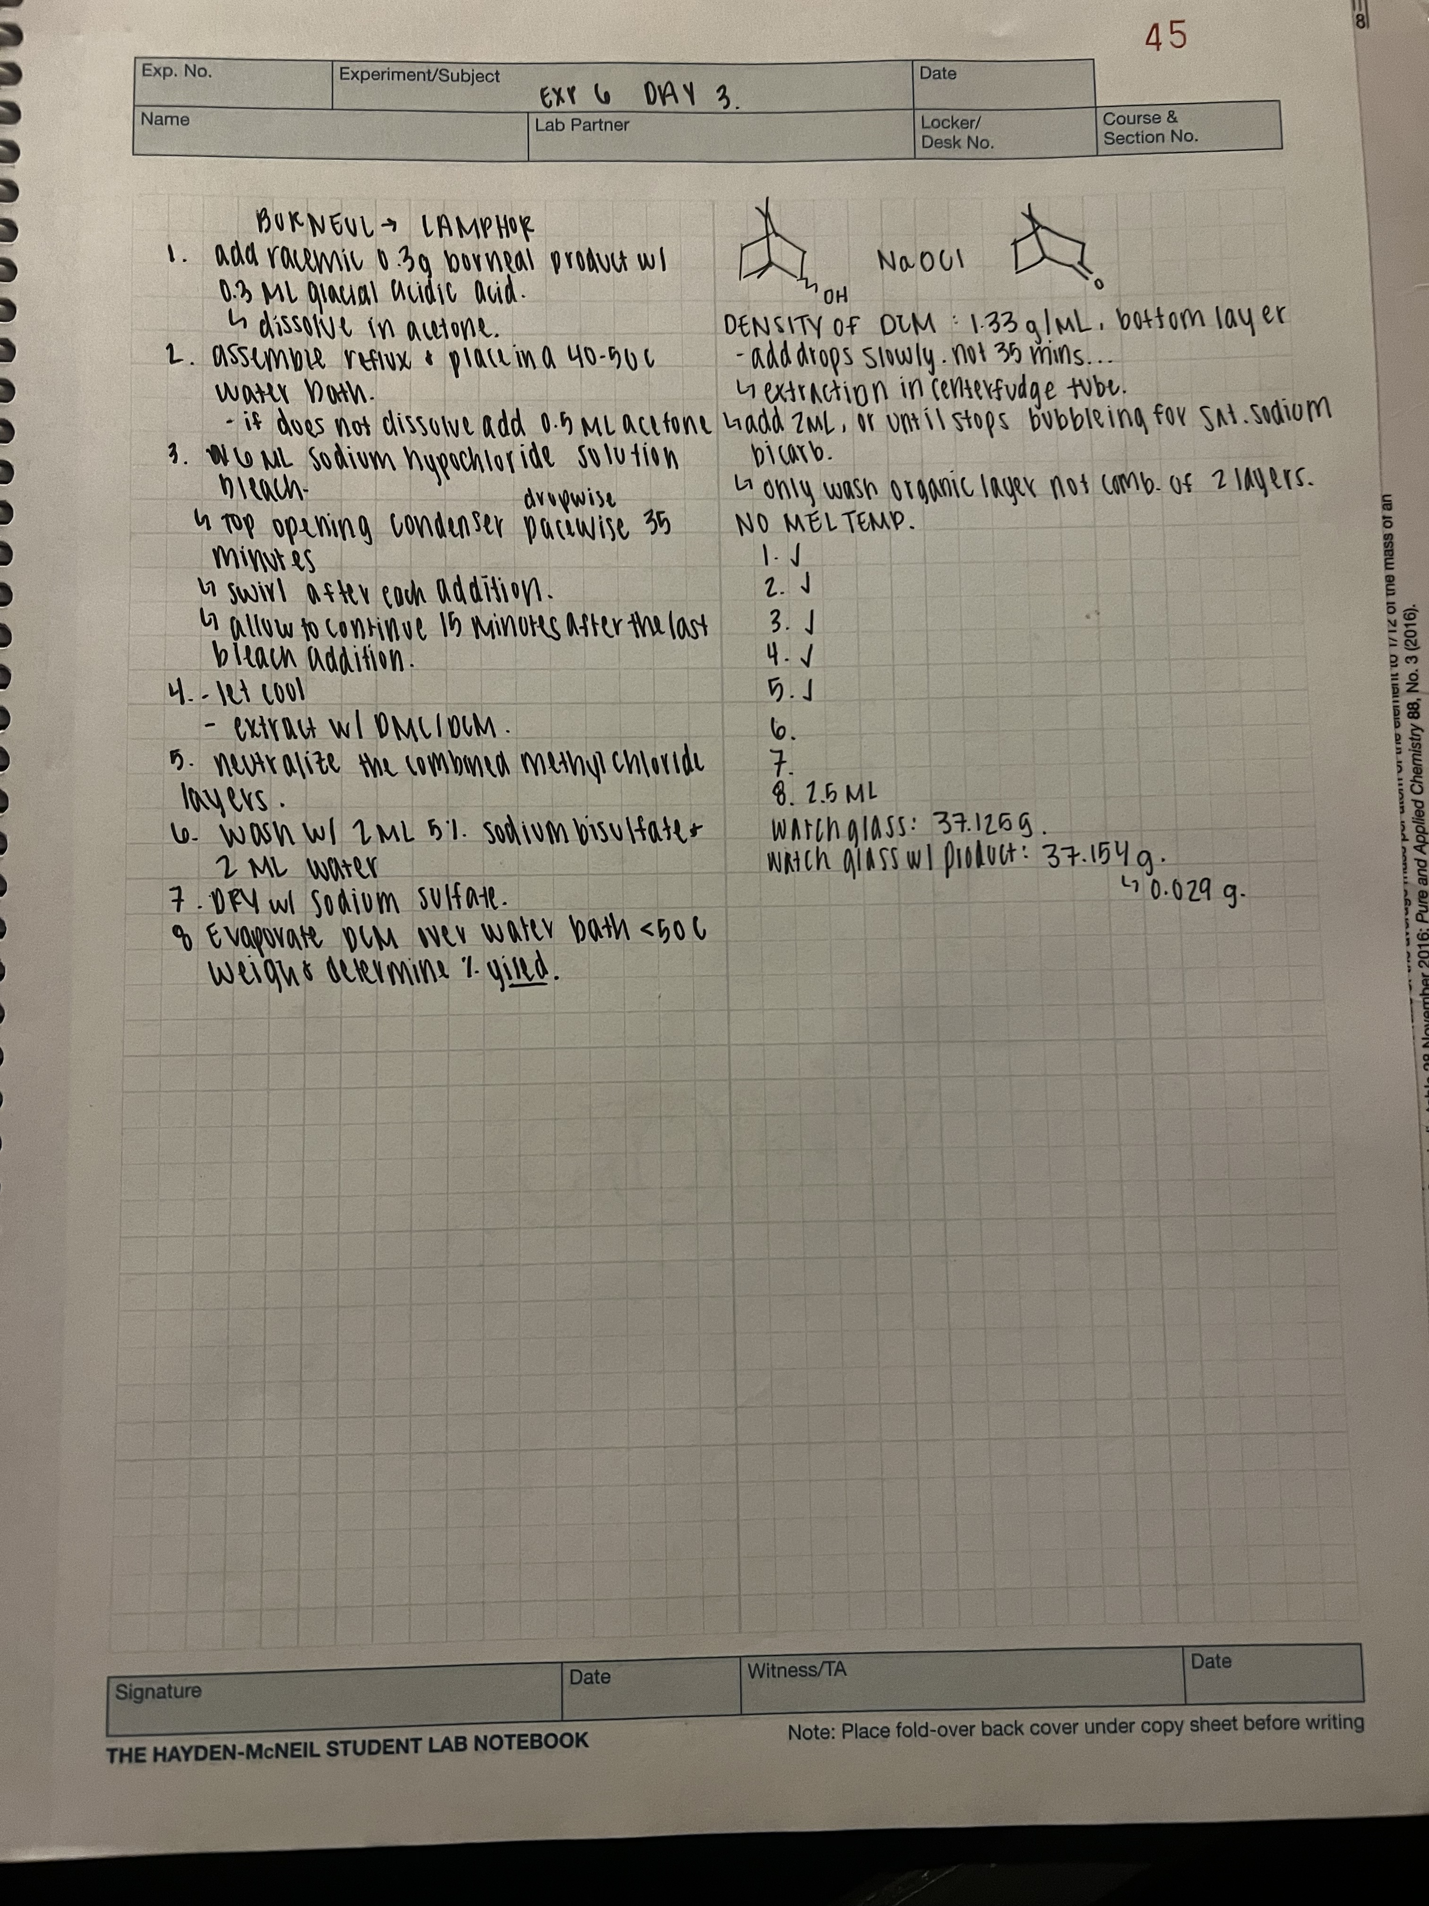
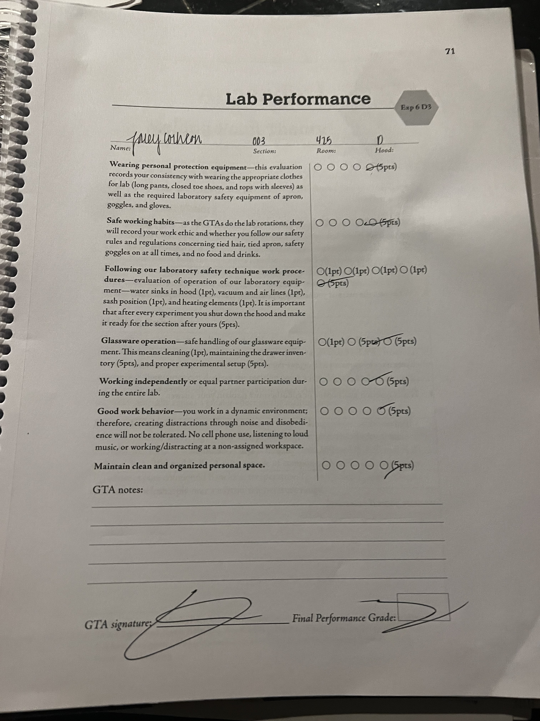
Introduction
In this experiment camphene, acetone, dichloromethane, acetic acid, an aqueous solution of sodium bicarbonate, sodium hypochloride, and borneol were utilized to create camphor through simple distillation techniques, extraction, and evaporation.
Materials and Methods
In a long neck round bottom flask, 0.3 mL of racemic borneol and 0.3 mL of glacial acetic acid were dissolved with 1 mL of acetone. A simple distillation column was assembled according to Figure 1-8 in the Chem 2081 Manual. 0.5 mL of acetone was added to aid the dissolution. After the reagent dissolved, 6 mL of aqueous sodium hypochloride solution (bleach) was added dropwise. The reaction was allowed to reflux for fifteen minutes. The mixture was then allowed to cool and two portions of 2 mL of DCM were used to extract the camphor. The organic layer was then treated with 2 mL of saturated sodium bicarbonate to neutralize the acid residuals. Next, the organic solution was washed sequentially with 2 mL of sodium bisulfite and 2 mL of water. Finally, the organic solution was dried with anhydrous sodium sulfate and the remaining DCM was evaporated over a water bath. (Keller 2023).
Results
Watch Glass Weight | 37.125 g
Watch Glass + Product | 37.254 g
Final Product (Camphor) | 0.129 g
Percent Yield | 43.58 %

Calculations
0.3 gram Borneol / 154.25 g/mol (molecular mass of borneol) = 0.0019449 mols
0.0019449 mols x 152.23 g/mol (molecular mass of camphor) = 0.296 grams
0.129 grams / 0.296 grams x 100 = 43.58%
Discussion
In this experiment, borneol was treated with glacial acetic acid and acetone to dissolve in temperatures of 40-50 C. The water bath had to remain within the temperature range due to the low boiling point of the reagents. Since the borneol was dissolved in the reagent the temperature must be closely monitored through this portion of the reaction or a loss of product could occur. A way to avoid this would be to utilize a closed reflux system, rather than an open simple distillation. After the reagents were dissolved, bleach was added to the solution. The bleach was added slowly due to the exothermic nature of the addition. If the drops were added all at once bubbling and splashing could occur which could result in a loss of product and chemical burns. Then the camphor was extracted with dichloromethane. The organic layer was located in the top layer because DCM has a density of 1.33 g/mL, while aqueous solutions tend to have closer to 1.00 g/mL. The solution then was neutralized, washed, and dried. The last step was evaporation, which also was completed within the temperature range of less than 50 C. DCM has a boiling point of 39.8 C and if the temperatures exceed 50 C will result in more than the evaporation of DCM, which can affect product yield.

References
Keller L, Joseph K, and Miguel S. 2023 Fall. CHEM 2081 Organic Chemistry II Lab Manual [lab manual]. Auburn (Al): Auburn University.

